The Catcher in The Rye Pre-reading Webquest
Use the links that appear below each question to answer the questions.

1. Why would a book be banned/challenged?
http://libguides.butler.edu/bannedbooks?p=217686

The book would be barred if the opinion might be unpopular or unorthodox.

2. Where was Catcher on the list in 2009?
http://www.ala.org/bbooks/frequentlychallengedbooks/top10

Number 6.

3. What are the reasons for Catcher being banned?
http://blogs.bl.uk/english-and-drama/2016/09/banned-from-the-classroom-censorship-and-the-catcher-in-the-rye.html

The book was canceled for several reasons, for instance, the use of 1950 teenage slang and instances of abuse. Also, the book contains a majority of disturbing scenes. The book also contains sexual content and swearwords.

4. Who was JD Salinger? Read his biography and summarize what you find below: http://en.wikipedia.org/wiki/J._D._Salinger

JD Salinger was a well-known writer of short stories such as “The Catcher Rye" and "The New Yorker."JD graduated from a series of colleges, including one where he met a professor who encouraged him to write and publish more work since the professor spotted Salinger's talent. As mentioned above, the writer served in the military for 2years as he continued with the book-writing work. However, his stories on “The Catcher Rye” book got negative reviews due to its content, which later led to its cancellation.

5. Catcher in the Rye is referred to throughout popular culture. List some of the music/tv/films in which it has been mentioned: http://en.wikipedia.org/wiki/The_Catcher_in_the_Rye_in_popular_culture

Some films that mentioned “The Catcher Rye” are the "good girl," "Chasing Holden," and "Conspiracy Theory." The tv show that mentions the novel is "south park," "the tale of scrotie of mcboogerballs," and "ghost in the shell: stand-alone complex." The books that mention “The Catcher Rye” in the novel are "the collector," "burglar in the eye," and "coming through the rye." Some music that mentions the book includes "we didn't start the fire" and "who wrote Holden Caulfield."

6. What was happening in the United States in the 1950s?
https://en.wikipedia.org/wiki/Timeline_of_United_States_history
Name two key political facts/events, and explain why they are significant to the time period (and perhaps the novel).

A.Arrival of Native Americans
The arrival of the Native Americans constituted to the civilization of the indigenous communities

b. Civil war
The civil war forced technological advancement in warfare.

7. Explore the fashion trends for men, women, and children during the 1950s. What do you notice? How does it differ from today's clothing?
http://www.fiftiesweb.com/fashion/fashion-w.htm
Women dresses were about a tailored look good grooming. Gloves and heels completed the look for women. For men, fuller suits were the main fashion. Their workplace choices of color were charcoal, blue, dark blue, and brown. Children's clothes include taped pants with shoestring ties, and cotton shirts were popular. The styles differ since people are influenced by known culture, popular television shows, and social media.

- Read about family life during the 1950s. What are some significant points? How do families today differ? http://www.fiftiesweb.com/pop/info-family.htm
The rich took their kids to prep schools while the poor depended on the public schools for educating their kids. Poor and ordinary families had little or no spare money for treats like holidays and cinema trips. Most families played board games since there were no computers.

9. Explore “prep schools” in the 1950s. What do you notice? http://www.ehow.com/info_7988082_prep-schools-1950s.html

The boys' higher number caused the boom in prep school attendance in 1950 .also most of the prep schools operated as boarding schools. Since the students lived miles away from the prep schools, the teachers believed boarding school would help build a boy's character. Besides, the institutes were not co-ed. Boys went to school intending to get into the finest universities while ladies went to school to become refined young females.

10. Attach images of the following:
- Map of New York in the 1950’s and circle Central Park.
- Central Park merry-go-round
- Central Park Duck Pond
a) 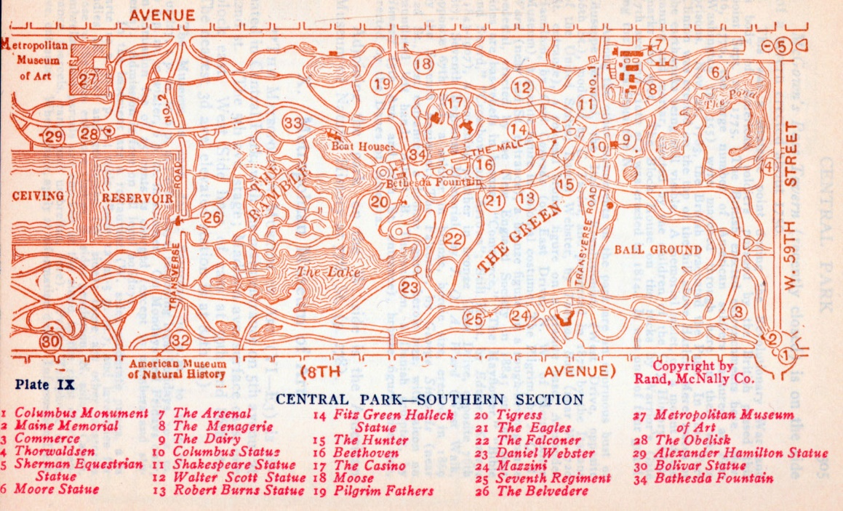

b) 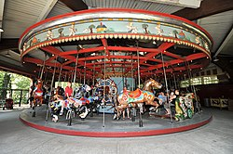

l

c) 